A Reproducible Differential Gene Expression Analysis of Inflammatory and Normal/Reactive Synovial Tissue Regions in Osteoarthritis Using GEO Dataset GSE46750

Abstract
Osteoarthritis (OA) is a chronic joint disease involving changes in articular cartilage, subchondral bone, and synovial tissue. Synovial inflammation can vary within the joint and may be associated with changes in immune signaling and tissue-related gene expression. This project reanalyzed the publicly available Gene Expression Omnibus (GEO) dataset GSE46750 to compare inflammatory and normal/reactive synovial tissue regions from patients with OA. Expression data were analyzed in R using the limma framework and a paired design that accounted for patient identity. Probes with an adjusted p-value below 0.05 were considered statistically significant. The analysis identified 152 significant probes: 120 had positive log2 fold changes and 32 had negative log2 fold changes for inflammatory relative to normal/reactive regions. These probes represented 137 unique annotated gene symbols. Among the top-ranked probes were CD48, MATN2, SNTB1, MAN1C1, IRF8, TNFRSF21, LRRN1, CCL2, PLA2G7, and AHNAK. A volcano plot and a heatmap of the 20 most statistically significant probes were generated. These results indicate regional gene-expression differences within OA synovial tissue. They do not establish causal mechanisms and should not be interpreted as an OA-versus-healthy comparison. Independent validation and careful biological interpretation are needed.
Keywords: osteoarthritis; synovial tissue; differential gene expression; GEO; GSE46750; limma; microarray; bioinformatics

1. Introduction
1.1 Osteoarthritis and joint-tissue biology
Osteoarthritis is a heterogeneous, whole-joint disorder characterized by structural and functional changes in several tissues, including articular cartilage, subchondral bone, synovium, ligaments, and periarticular structures. Cartilage matrix degradation is an important feature, but OA biology also involves altered mechanical loading, cellular stress responses, inflammatory signaling, and changes in tissue homeostasis. These interacting processes contribute to symptoms such as pain and stiffness and to progressive loss of joint function.

1.2 Synovial inflammation in OA
The synovial membrane lines the joint cavity and contributes to the maintenance of synovial fluid and the intra-articular environment. In OA, some synovial regions show inflammatory changes, including activation of resident cells, immune-cell recruitment, and altered expression of cytokines and chemokines. These local responses may interact with cartilage and other joint tissues. The extent of inflammation can differ between patients and between tissue regions from the same patient, making regional comparisons informative.
Gene-expression differences can point to biological processes associated with inflammatory regions, but expression associations alone cannot show that a gene causes inflammation or disease progression. Results must be interpreted in the context of the sampling design and supported by independent evidence.

1.3 Microarray data and computational analysis
Microarray experiments measure the relative abundance of transcripts represented by many probes. Public repositories such as the NCBI Gene Expression Omnibus (GEO) make these data available for reanalysis. Computational reanalysis can help identify expression differences without collecting new samples, provided that the original experimental design, preprocessing, probe annotation, and statistical assumptions are considered.
The limma package for R fits linear models to expression data and uses empirical Bayes methods to moderate variance estimates. For paired samples, subject terms can be included in the design matrix to account for patient-specific differences. Since thousands of probes are tested simultaneously, adjusted p-values are used to control the false discovery rate. Volcano plots summarize fold change and statistical evidence, while heatmaps show relative patterns across selected probes and samples.

1.4 Rationale for GSE46750
GSE46750 includes gene-expression measurements from inflammatory and normal/reactive synovial tissue regions collected from patients with OA. The paired nature of the sampling permits a within-patient comparison, reducing the influence of stable differences between individuals. This project reanalyzes the dataset using a paired statistical design to identify probes associated with regional inflammatory status.

1.5 Aim and objectives
Aim: To identify differentially expressed probes between inflammatory and normal/reactive synovial tissue regions in OA using the public GEO dataset GSE46750.
- Obtain and inspect the GSE46750 expression matrix and sample metadata.
- Analyze expression differences using R and limma with patient identity represented in the statistical design.
- Identify significant probes using an adjusted p-value threshold of less than 0.05.
- Annotate significant probes with gene symbols and summarize the leading results.
- Visualize results using a volcano plot and a heatmap of the 20 most statistically significant probes.
- Organize output tables and figures for transparent reporting and GitHub sharing.

2. Materials and Methods
2.1 Dataset
The analysis used GEO series GSE46750 and the Illumina Human v4 microarray platform (GPL10558), as documented in the project workflow. The analyzed matrix contained 47,231 probes across 24 samples. The samples comprised 12 normal/reactive regions and 12 inflammatory regions from 12 OA patients, with each patient represented in both groups.

2.2 Expression data and transformation
The expression matrix used in the analysis contained 47,231 rows and 24 sample columns. The expression values were transformed using log2(expr), as confirmed during the workflow. The original dataset's processing and normalization details should be reported from the GEO record or original study; this report does not assume that quantile normalization was newly performed during this reanalysis.

2.3 Paired statistical design
A design matrix was constructed in R using a model of the form ~ Subject + Group, with normal/reactive samples as the reference group and inflammatory status as the group effect. This design accounts for patient-specific baseline differences. The model matrix was confirmed to be full rank in the recorded workflow. Positive log2 fold changes are interpreted as higher expression in inflammatory regions relative to normal/reactive regions, provided the group reference coding is as described.

2.4 Differential expression and multiple-testing correction
Differential expression was estimated using limma. Probe-level results included log2 fold change, average expression, moderated t-statistic, raw p-value, adjusted p-value, and B-statistic. Probes with adjusted p-values below 0.05 were designated statistically significant. The exact preprocessing, annotation package version, and code used to fit the model should accompany the repository for full reproducibility.

2.5 Probe annotation and visualizations
Probe-level results were annotated with gene symbols and gene names. The significant-probe table contained 152 rows and nine columns. A volcano plot displayed log2 fold change against the negative log10 of adjusted p-value, with positive significant changes colored red, negative significant changes blue, and nonsignificant probes grey. A heatmap was generated for the 20 most statistically significant probes using expression values standardized across samples for each probe. The heatmap used hierarchical clustering to organize rows and columns.

2.6 Reproducibility and data organization
CSV result tables and PNG figures were copied into a project folder, and a README file was created to describe the dataset, outputs, and key limitations. For complete reproducibility, the repository should also include the R script or notebook, R and package versions, the sample metadata table, and clear instructions for obtaining the original GEO data.

3. Results
3.1 Dataset and model overview
The analyzed expression matrix contained 47,231 probes measured in 24 samples. The comparison involved 12 inflammatory samples and 12 normal/reactive samples from the same 12 OA patients. The paired design included subject terms to account for within-patient matching.

3.2 Significant differential-expression results
At an adjusted p-value threshold of less than 0.05, 152 probes were identified as significant. Of these, 120 had positive log2 fold changes and 32 had negative log2 fold changes for inflammatory relative to normal/reactive regions. The significant probes corresponded to 137 unique annotated gene symbols. The counts describe probes and unique symbols separately because multiple probes may map to the same gene.

Metric | Result
Samples analyzed | 24
Patients represented | 12
Significant probes (adjusted p < 0.05) | 152
Positive log2 fold change | 120
Negative log2 fold change | 32
Unique annotated gene symbols | 37

3.3 Top-ranked probes
The ten top-ranked probes by adjusted p-value included CD48, MATN2, SNTB1, MAN1C1, IRF8, TNFRSF21, LRRN1, CCL2, PLA2G7, and AHNAK. All ten had adjusted p-values below 0.05. PLA2G7 had the largest positive log2 fold change among these ten probes (1.223), while MATN2 had the largest negative log2 fold change (-0.935).
Gene symbol | log2 fold change | Adjusted p-value
CD48 | 0.8083 | 0.02243022
MTN2 | -0.9352 | 0.02243022
SNTB1 | 0.3778 | 0.02243022
MAN1C1 | 0.6739 | 0.02416472
IRF8 | 0.6869 | 0.02744388
TNFRSF21 | 0.9950 | 0.02744388
CCL2 | 0.7619 | 0.02744388
LRRN1 | -0.4783 | 0.02744388
PLA2G7 | 1.227 | 0.02744388
AHNAK | -0.5654 | 0.02744388

3.4 Volcano plot
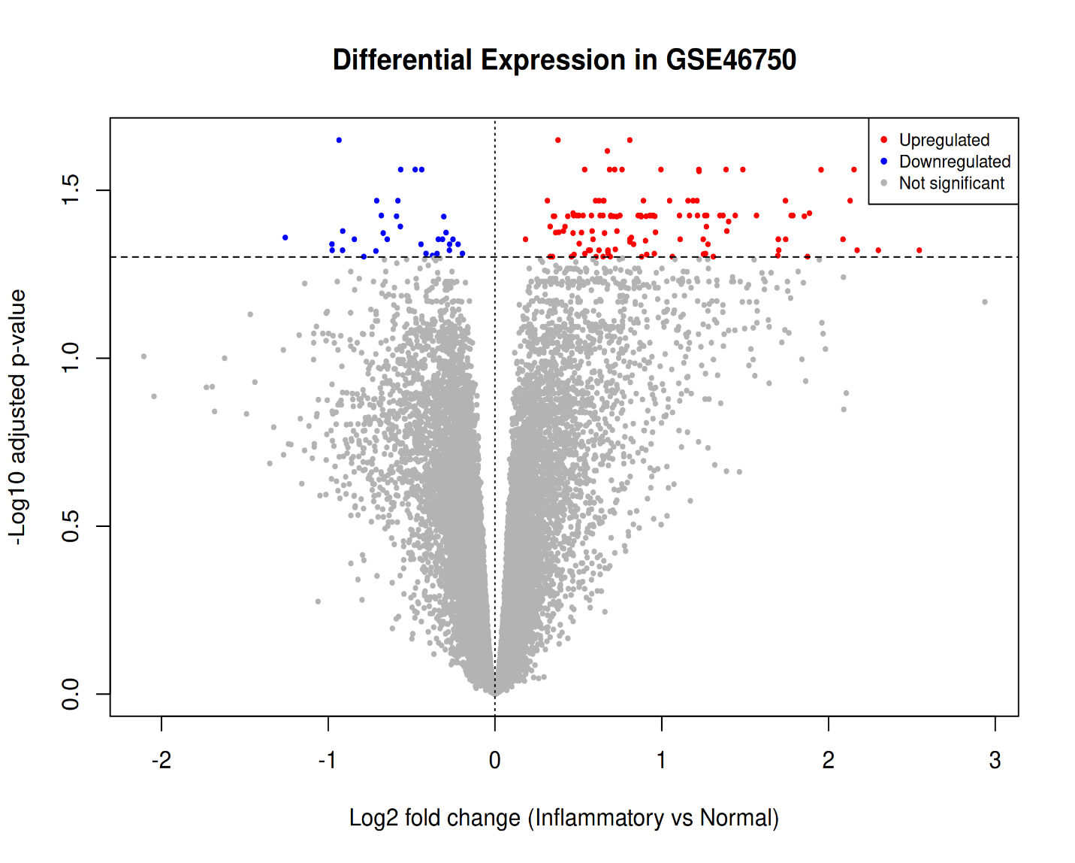
Figure 1 shows the relationship between log2 fold change and adjusted p-value across the tested probes. Red points indicate significant positive changes, blue points indicate significant negative changes, and grey points indicate probes that did not meet the adjusted p-value threshold. The plot provides an overview of the distribution of differential-expression results.

Figure 1. Volcano plot of differential-expression results for GSE46750.

3.5 Heatmap of the top 20 probes
Figure 2 displays standardized expression patterns for the 20 most statistically significant probes across the 24 samples. The colors represent relative expression for each probe after row-wise standardization, rather than absolute expression abundance. Hierarchical clustering organizes samples and probes by similarity. The displayed heatmap does not explicitly annotate the sample groups, so clustering should not be treated as a formal test of group separation.
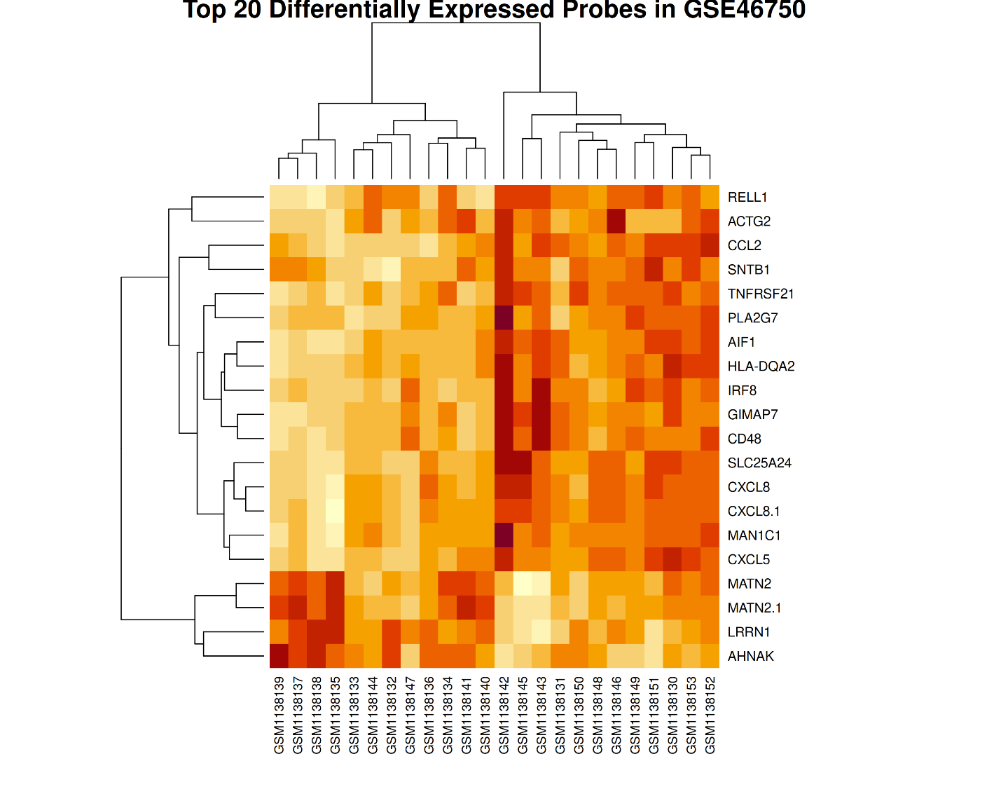

Figure 2. Heatmap of standardized expression for the top 20 significant probes.

4. Discussion
This reanalysis identified 152 significant probes distinguishing inflammatory from normal/reactive synovial regions within OA patients. The positive and negative log2 fold changes indicate that expression changes occurred in both directions, suggesting that inflammatory regions are characterized by a mixture of increased and decreased transcript abundance rather than a uniform increase across all genes.
Among the leading results, CCL2 is a chemokine commonly associated with immune-cell recruitment, while CD48 and IRF8 are associated with immune-cell biology. PLA2G7 is involved in lipid-related biology. MATN2 is related to extracellular-matrix biology. These annotations provide possible context for follow-up, but they do not establish that the genes or pathways are causal in the tissue comparison. Bulk-tissue expression can also be influenced by changes in cell composition as well as changes in transcription within individual cell types.

The paired design is a strength because each patient's inflammatory region is compared with that same patient's normal/reactive region, helping account for patient-level variation. Reuse of a public dataset also makes the project cost-effective and supports transparent computational research. The volcano plot provides a compact summary of significance and effect direction, while the heatmap illustrates variation among selected probes.
The findings should be interpreted as regional associations within OA synovium. The study does not include a healthy-control comparison in this analysis, and therefore cannot establish which expression differences are specific to OA compared with healthy tissue. Further pathway-level interpretation should be based on the actual GO enrichment outputs, including the background gene universe and multiple-testing method, and should be checked for overrepresentation and annotation biases.

5. Limitations

- The analysis uses a limited cohort of 12 patients, which may constrain statistical power and generalizability.

- The comparison is between inflammatory and normal/reactive regions from OA patients, not OA tissue versus healthy control tissue.

- Microarray probe measurements and gene annotation can be affected by probe specificity, outdated annotations, and multiple probes mapping to one gene.

- Differential expression indicates statistical association and does not establish causality or protein-level changes.

- Bulk-tissue expression differences may reflect changes in cellular composition as well as changes in gene expression within cells.

- The heatmap lacks explicit sample-group annotations, so it should be interpreted as an exploratory visualization.

- The complete analysis script, software versions, and dataset preprocessing details should be included before claiming full computational reproducibility.

- The original dataset's normalization and preprocessing must be described from the GEO record or original publication, not inferred solely from the log2 transformation.

6. Conclusion
The GSE46750 reanalysis identified 152 significant probes associated with differences between inflammatory and normal/reactive synovial tissue regions in OA, representing 137 unique annotated gene symbols. Among the top-ranked findings were CD48, IRF8, CCL2, PLA2G7, and MATN2. The volcano plot and heatmap summarize the statistical and expression-pattern results. These findings provide a set of candidates for further investigation of regional synovial biology, but experimental validation and additional datasets are needed to assess their robustness and biological significance.
7. Data and code availability
The dataset is publicly available through the NCBI Gene Expression Omnibus under accession GSE46750. The project output folder contains annotated probe results, significant-probe results, differential-expression tables, GO-related output tables, candidate-gene results, and figure files. Add the exact repository URL after publishing the project on GitHub. To support reproducibility, include the R script or notebook and session/package information.

